This Week’s Hymn and Message:
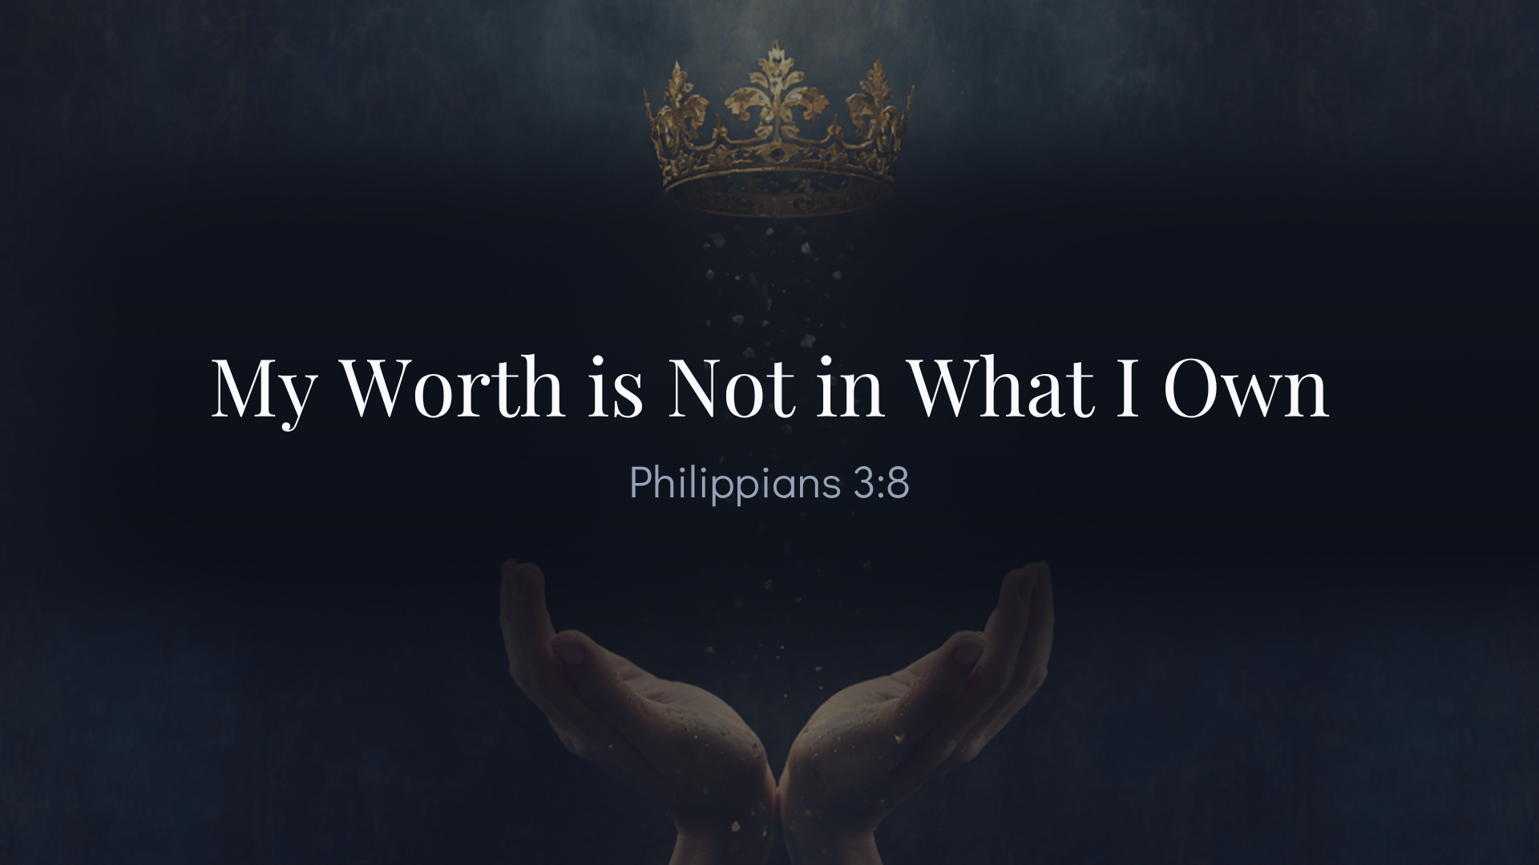
This song was written in 2014 and was inspired by Graham Kendrick who took the idea to a writing session with Keith and Kristyn Getty and the song was birthed. The intent was to craft a congregational hymn that contrasted the world’s obsession with wealth, power, status, and achievement with God’s very different value system. Theologically (or Scripturally, the hymn is deeply tied to 1 Peter 1:18-19 regarding the redemption paid for our salvation. And Philippians 3:7-8 where Paul counts worldly gains as loss and the surpassing worth of knowing Christ Jesus as Lord. The context of Phil.3 is Paul is writing to the infant church in Philippi. The local church there was embroiled in an internal scandal no thanks to a few from the circumcision party (Judiazers). Paul’s ministry which planted the church was taking on a full assault by what Paul called, “a crooked and perverse” generation (2:15). False teachers were insisting that Gentiles add certain Mosaic laws to be further accepted by Christ. They have caused such unrest among the church and even questioned Paul’s message and Apostleship. Paul had become quite anxious over the tension caused by dishonest locals (2:28). Paul’s intent is stated clearly that he does not want their faith to be troubled and for the safeguard of the gospel they first believed from him (3:1). Warning the church of the “dogs and evil workers, and those who want to mutilate the flesh (circumcision),” Paul turns his attention to credentials that don’t matter and have no advantage. Found in Philippians 3:5-6, Paul lays an ax to any assets he may have in this world and considers them loss for the sake of Christ. Paul calls these things “dung,” or “trash.” The only thing worth claiming is the surpassing worth of knowing Christ, his sufferings.
NONE of these privileges held any value for Paul. They were of no advantage. The importance of this is to show the early church in Philippi and today that none of these assets count for anything. Paul was glad to write these things as he had learned the definition of true success in the mind of God. What have you given up or laid down in order to have the same mind of Christ? What have you determined to be worth the investment of time, energy and money that will reflect the Kingdom of God and his values? In what ways do you think Jesus and his purposes are served by the life you are pursuing?
The word “know” is tricky in these verses. There are two types of knowledge. There is intellectual knowledge (head knowledge) which does not lead to a changed life. This kind of knowledge leads to further blindness and/or self-righteousness. It is a dangerous thing to study the Bible and not have one’s life constantly amended by the light and presence of word/Spirit. For example, Jesus can be famous in our minds but not followed with our hearts. We live in a culture where Jesus is famous but not a culture where Jesus is followed. What might this suggest about our churches? Are we following the way of Jesus or Is Jesus just famous among us?
The word “Know” in this text is about the heart and about experiential knowing. It would sound like, “I know this because I obey this. And through obedience I experience the blessing, freedom, and peace of Christ.” This knowledge is not book smarts but wisdom by imitation.
The world measures value by possessions, abilities, titles, achievements, income and reputation. But this hymn begins with a radical declaration: “My worth is not in what I own, Not in the strength of flesh and bone, But in the costly wounds of love - at the cross.” The Christian’s worth is not self-created. It is Christ-given.
By grace believing,
Preston

